**Project Name:** Birds Species Classification

**Github Link:** https://github.com/projectsforstudents2022/Birds_Species_Prediction.git

**Why was this project created?**

There are more than 9000 species of birds on the globe. Some bird species are uncommonly discovered, and when they are, prediction is quite challenging. We have a quick and easy method to identify these bird species based on their traits in order to solve this issue. However, visual recognition of birds by humans is more comprehensible than audible recognition of birds.

**What problem is it solving?**

Identifying a particular species might be difficult even for experienced birders. It might also be overwhelming to know where to start looking in the hundreds of pages of species if you've never used a field guide before. Birds can be grouped together based on characteristics like size, shape, and color. The species of birds can be categorized using CNN.

**Entire explanation of project**

* **PROPOSED APPROACH**

A multilayer perceptron with a specific architecture for identifying two-dimensional picture data is the convolution neural network algorithm. Input layer, convolution layer, sample layer, and output layer are the four layers that make up this algorithm. The sample layer and convolution layer in a deep network architecture could have more than one. With convolution neural network techniques, each neuron just has to feel the local portion of the image rather than the entire image, unlike the Boltzmann machine, which requires that it be before and after the layer of neurons in the neighboring layer for all connections. Additionally, each neuron's parameters are specified to be the same, including the sharing of weights and the use of identical convolution kernels for the deconvolution picture for each neuron.

The central elements of CNN are the local receptive field, weight sharing, and time- or space-based subsampling with the aim of feature extraction and training parameter reduction. The benefit of the CNN algorithm is that it learns intuitively from training data rather than explicitly extracting features. The network can learn in parallel and become less complex because the same neuron weights are on the surface of the feature mapping. adopting a sub-sampling structure based on deformation displacement, scale, and time resilience. Network topology and input data may go well together. It offers special benefits for picture processing. These actions are part of the Convolution Neural Network.

Algorithm for creating next word prediction model :

**Step 1:** Import Libraries & Load Dataset

**Step 2:** Image Preprocessing

**Step 3:** Initialize the CNN

**Step 4:** Compiling the CNN

**Step 5:** Train Model

**Step 6:** Testing & Visualization

* **DATA FLOW DIAGRAM**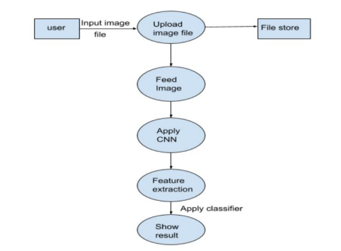
* **RESULT**

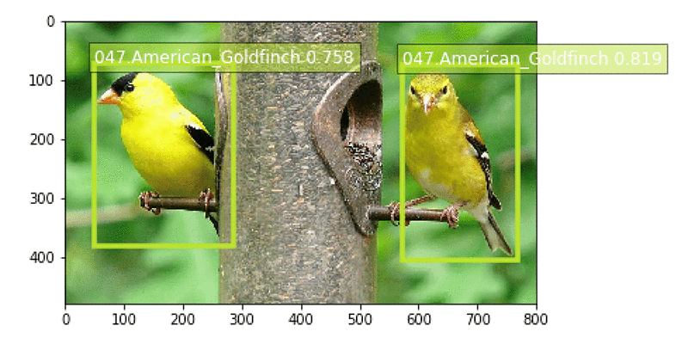

* **CONCLUSION**

The primary goal of the identification project is to increase public awareness of bird-watching, identification, and particularly the identification of species found in India. It also meets the requirement to make bird-watching simpler by streamlining the identifying procedure. Convolutional Neural Networks are the technology utilized in the experimental setup (CNN). It recognises images using feature extraction. The technique employed is adequate for feature extraction and picture classification.